**Name : Muhammad Usman**

**Father’s Name : Muhammad Ilyas**

TASK – 1:

Build A SIMPLE STATIC WEBSITE USING HTML AND CSS, Showcasing your personal profile or a hobby.

**HTML CODE For First/Home Page >**

<!DOCTYPE html>

<html lang="en">

<head>

    <meta charset="UTF-8">

    <meta name="viewport" content="width=device-width, initial-scale=1.0">

    <title>Document</title>

    <style>

        body{

            box-sizing: border-box;

            margin: auto;

            background-image: radial-gradient(blueviolet, grey, red);

        }

        ul{

          list-style-type: none;

          margin: 0;

          padding: 0;

          overflow: hidden;

          background-color:blue

        }

        li {

          float: left;

        }

        li a {

          display: block;

          color: white;

          text-align: center;

          padding: 14px 16px;

          text-decoration: none;

        }

        li a:hover {

          background-color: red;

        }

        .cl0{

          background-color:#111;

        }

        .img{

            border-radius: 50%;

            padding-left: 40px;

        }

        div{

            border-radius: 30px;

        }

        .div2{

            float: right;

        }

        footer {

   position: fixed;

   left: 0;

   padding:12px;

   bottom: 0;

   width: 100%;

   background-color:green;

   color: white;

   text-align: center;

}

footer:hover{

    background-color: rgb(71, 16, 16);

}

        </style>

</head>

<body>

    <ul>

        <li><a href="home.html">Home</a></li>

        <li><a href="interest.html">My Interest</a></li>

        <li><a href="contact.html">CONTACT US</a></li>

        <li style="float:right"><a class="cl0" href="blog.html">My Hobbies</a></li>

        <li style="float:right"><a class="cl0" href="about.html">ABOUT Me</a></li>

      </ul><br><br><br>

    <div style="float: left; background-image: linear-gradient(green, grey, orange);" >

    <img class="img" src="c:\Users\COMPUTER\Downloads\WhatsApp Image 2024-07-04 at 12.12.05 PM.jpeg" alt="" width="200px" height="200px">

    <p style="padding-left: 70px;">Muhammad Usman</p>

    <h4 style="padding-left: 80px;">Web Developer</h4>

</div>

<div class="div2">

    <h1 style="padding-right: 350px; padding-top: 20px; padding-bottom: 20px; padding-left: 20px; border-radius: 10px; background-image: linear-gradient(red, blue, green); color: white;">PERSONAL PORTFOLIO</h1><br>

<p style="font-family: 'Segoe UI', Tahoma, Geneva, Verdana, sans-serif;"><b style="padding-right: 100px; padding-left: 36px;">Name: </b>Muhammad Usman</p>

<p style="font-family: 'Segoe UI', Tahoma, Geneva, Verdana, sans-serif;"><b style="padding-right: 100px; padding-left: 36px;">Father's Name: </b>Muhammad Ilyas</p>

<p style="font-family: 'Segoe UI', Tahoma, Geneva, Verdana, sans-serif;"><b style="padding-right: 100px; padding-left: 36px;">CNIC: </b>37103-4534098-9</p>

<p style="font-family: 'Segoe UI', Tahoma, Geneva, Verdana, sans-serif;"><b style="padding-right: 100px; padding-left: 36px;">Contact No: </b>0312-34358766</p>

<p style="font-family: 'Segoe UI', Tahoma, Geneva, Verdana, sans-serif;"><b style="padding-right: 100px; padding-left: 36px;">Email ID: </b>usmancadet@gmail.com</p>

<p style="font-family: 'Segoe UI', Tahoma, Geneva, Verdana, sans-serif;"><b style="padding-right: 100px; padding-left: 36px;">Educational Level: </b>BS Software Engineering</p>

</div><br>

<footer>

    <p>Muhammad Usman<br><br>

    <a href="copyright.M.Usman">@2024.All Rights reserved.</a></p>

  </footer>

</body>

</html>

**Output When Open in Chrome Browser:**

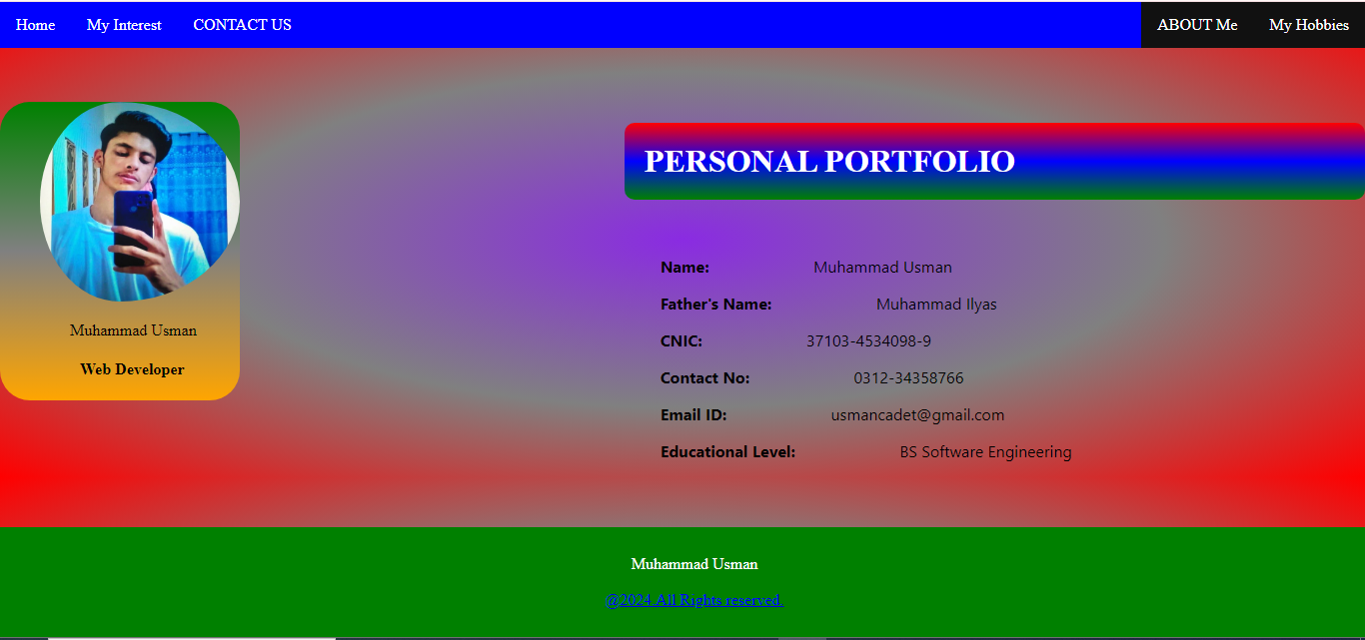

**HTML CODE For Interest Page >**

<!DOCTYPE html>

<html lang="en">

<head>

    <meta charset="UTF-8">

    <meta name="viewport" content="width=device-width, initial-scale=1.0">

    <title>Document</title>

    <style>

        body{

            box-sizing: border-box;

            background-image: radial-gradient(grey, lightgreen,lightblue)

        }

                .c0{

    text-align: center;

     padding-top: 20px;

      padding-bottom: 20px;

      padding-left: 20px;

       border-radius: 10px;

        background-image: linear-gradient(red, blue, green);

color: white;}

div{

    background-color: cadetblue;

    color: azure;

    padding: 20px;

    text-align: justify;

    font-family: Cambria, Cochin, Georgia, Times, 'Times New Roman', serif;

    font-size: larger;

    border-radius: 20px;

}

    </style>

</head>

<body>

    <h1 class="c0">Area Of Interest</h1><br>

    <div>

        <p>I am passionate about a variety of fields that inspire me and drive my curiosity. My interests range from exploring the latest advancements in technology and delving into creative design projects to engaging in community service and advocating for environmental sustainability. I believe in the power of continuous learning and personal growth, and I am dedicated to making a positive impact through my pursuits. Join me on this journey as I explore and contribute to the areas that excite me the most.</p>

        <p>Interested in Website Development</p>

        <p>Interested in WordPress Development</p>

    </div>

</body>

</html>

**Output When Go To My Interest Page in Chrome Browser:**

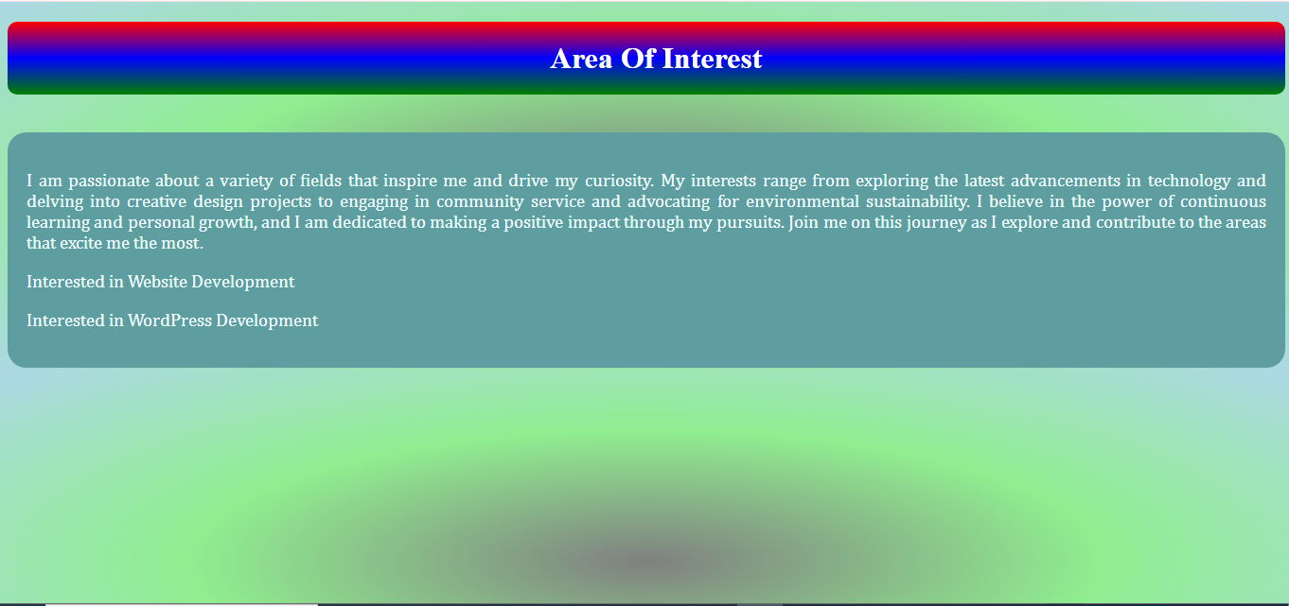

**HTML CODE For Contact Page >**

<!DOCTYPE html>

<html lang="en">

<head>

    <meta charset="UTF-8">

    <meta name="viewport" content="width=device-width, initial-scale=1.0">

    <title>Document</title>

    <style>

        body{

            box-sizing: border-box;

            background-image: radial-gradient(grey, lightgreen,lightblue)

        }

                .c0{

    text-align: center;

     padding-top: 20px;

      padding-bottom: 20px;

      padding-left: 20px;

       border-radius: 10px;

        background-image: linear-gradient(red, blue, green);

color: white;}

div{

    background-color: cadetblue;

    color: azure;

    padding: 20px;

    text-align: justify;

    font-family: Cambria, Cochin, Georgia, Times, 'Times New Roman', serif;

    font-size: larger;

    border-radius: 20px;

}

    </style>

</head>

<body>

    <h1 class="c0">FEEL FREE TO REACH US</h1><br>

    <div>

        <p>We'd love to hear from you! Whether you have questions, feedback, or need assistance, our team is here to help. Reach out to us by phone, email, or through our social media channels. Your inquiries are important to us, and we’ll get back to you as soon as possible.</p>

        <p><b>Contact Information: </b>0313-5299630</p>

        <p><b>Email ID: </b>usmancadet456@gmail.com</p>

    </div>

</body>

</html>

**Output When Go To Contact Us Page in Chrome Browser:**

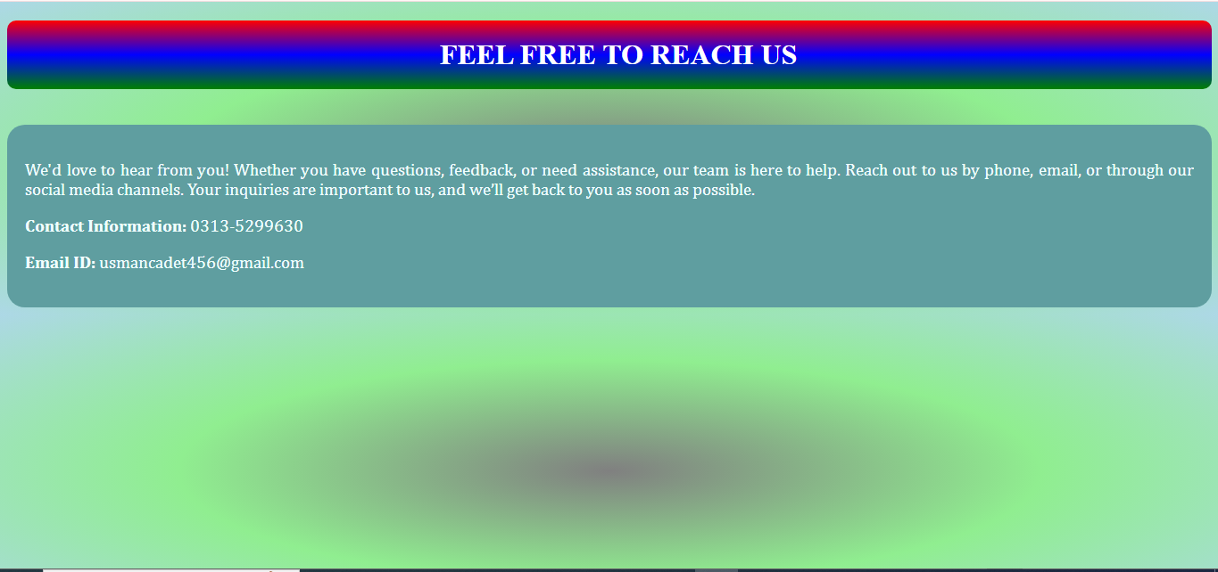

**HTML CODE For Blog Page >**

<!DOCTYPE html>

<html lang="en">

<head>

    <meta charset="UTF-8">

    <meta name="viewport" content="width=device-width, initial-scale=1.0">

    <title>Document</title>

    <style>

        body{

            box-sizing: border-box;

            background-image: radial-gradient(purple, red, green);

        }

        .c0{

    text-align: center;

     padding-top: 20px;

      padding-bottom: 20px;

      padding-left: 20px;

       border-radius: 10px;

        background-image: linear-gradient(red, blue, green);

color: white;}

div{

    background-color: cadetblue;

    color: azure;

    padding: 20px;

    text-align: justify;

    font-family: Cambria, Cochin, Georgia, Times, 'Times New Roman', serif;

    font-size: larger;

    border-radius: 20px;

}

    </style>

</head>

<body>

    <h1 class="c0">My Hobbies</h1><br>

    <div>

        <p>Love Playing Cricket</p>

        <p>Watching Television</p>

        <p>Listening To Music</p>

        <p>Watching Movies</p>

    </div>

</body>

</html>

**Output When Go To My Hobbies Page in Chrome Browser:**

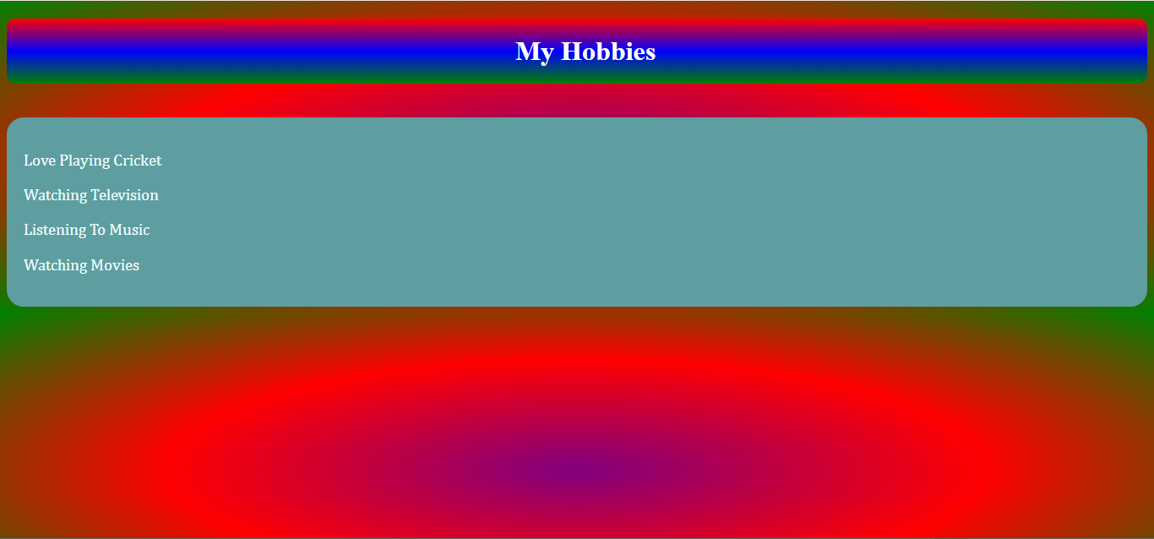

**HTML CODE For About Page >**

<!DOCTYPE html>

<html lang="en">

<head>

    <meta charset="UTF-8">

    <meta name="viewport" content="width=device-width, initial-scale=1.0">

    <title>Document</title>

    <style>

        body{

            background-image:linear-gradient(0, gray,green);

        }

.c0{

     padding-top: 20px;

      padding-bottom: 20px;

      padding-left: 20px;

       border-radius: 10px;

       text-align: center;

        background-image: linear-gradient(red, blue, green);

color: white;}

div{

    background-color: cadetblue;

    color: azure;

    padding: 20px;

    text-align: justify;

    font-family: Cambria, Cochin, Georgia, Times, 'Times New Roman', serif;

    font-size: larger;

    border-radius: 20px;

}

    </style>

</head>

<body>

<h1 class="c0">GET TO KNOW US</h1><br>

<div>

    <p>Welcome to our community! We are passionate about bringing people together and making a positive impact. Our mission is to provide valuable services and support that meet your needs. With a dedicated team and a commitment to excellence, we strive to create meaningful experiences for all our clients. Join us on our journey to make a difference!<br>Feel free to modify it to better suit your organization's voice and values.    </p>

    <p>I'm Student pursuing a Bachelor's Degree in Software Engineering</p>

</div>

</body>

</html>

**Output When Go To ABOUT Me Page in Chrome Browser:**

